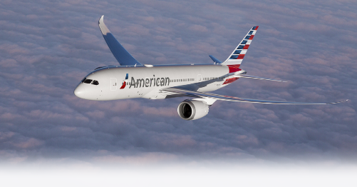 | 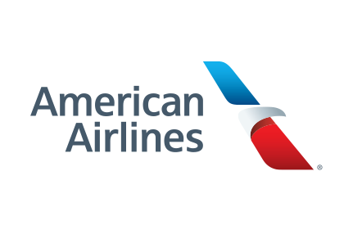
Hi John!

This is a notice from American Airlines. We are happy to let you know that we are offering you a discount on your next flight with us. This is because we realized that your last flight with us did not meet the high standards that we set for our passengers. So, to make up to you for that, we are offering you this deal. All you need to do to claim it is downloading the file attached to this message which contains your passenger information and a special code, and then go to this page (link placeholder) to enter your information along with the code number on the file. Your discount voucher will then be mailed to you within two weeks.

Warm regards
American Airlines

